Unit 6: Dichotomous Key for Acid Fast Bacteria, Candida albicans (Yeast), Endospores, Inclusion Bodies*, Capsules and Flagella.
By Patricia Wilber, Karen Bentz, Heather Fitzgerald, and Andrea Peterson, 2022
Creative Commons Attribution-NonCommercial 4.0 International License.

*Note to Instructors: prepare a slide of Priestia megaterium, Gram-stained, for your students to use for this lab. The slides will probably last all day if the light is turned off between classes. You can project the image on the board.

Introduction
A dichotomous key uses a series of two-answer (dichotomous) questions to identify unknown organisms. Dichotomous keys can be made in either written or flow-chart form. In this unit you will be observing endospores, flagella, capsules, bacteria that are identified via a staining technique called “Acid Fast”, and the eukaryotic yeast Candida albicans. Some of these features help the microbes succeed in their environment and aid in species identification. In the human body, some of these structures may contribute to pathogenicity and can be called virulence factors.

Acid Fast Bacteria
Organisms in the genera Mycobacterium and Nocardia have waxy mycolic acid in their cell walls, as well as a layer of peptidoglycan. (See Fig. 6-1) The mycolic acid layer absorbs the red stain carbolfuchsin. After decolorization with an acidic solution, organisms with mycolic acid retain the red carbolfuchsin stain, and are said to be “acid fast”. All other organisms lose the red and will stain blue or green, depending on the counter stain. Neither Gram (+) nor Gram (-) organisms have mycolic acid in their cell walls, so they are Acid Fast negative. If methylene blue is the counter stain, Acid Fast negative cells will be blue. If malachite green is used, Acid Fast negative cells are green.

Figure 6-1. Diagram of a bacterial cell wall containing mycolic acid; the blue layer is peptidoglycan.
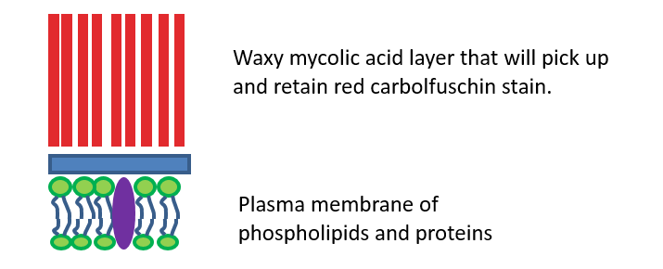
Image created by Patricia G. Wilber, 2015

Figure 6-2. Red bacillus-shaped Mycobacterium with blue epithelial cells.
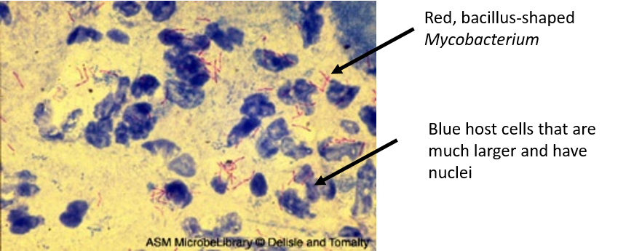
Accessed 4/11/2018 from https://bio.libretexts.org/TextMaps/Map%3A_Microbiology_(Kaiser)/Unit_1%3A_Introduction_to_Microbiology_and_Prokaryotic_Cell_Anatomy/2%3A_The_Prokaryotic_Cell%3A_Bacteria/2.3%3A_The_Peptidoglycan_Cell_Wall/2.3C%3A_The_Acid-Fast_Cell_Wall. Image from the American Society for Microbiology.

The Acid Fast technique is used to help diagnose tuberculosis (TB), caused by Mycobacterium tuberculosis (See Figure 6-2); leprosy, caused by Mycobacterium leprosae; and nocardiosis caused by Nocardia sp. A typical positive tissue stain will contain the red pathogen and tissue cells stained blue or green.

Candida albicans
Candida albicans is a species of yeast (Eukaryote, Kingdom Fungi) that normally lives harmlessly on our skin and mucosa. Candida can cause “yeast infections” in the genital area, thrush (in the mouth) or diaper rash (you know where that is). Overgrowth of Candida is also relatively common in those that are immune-compromised, during pregnancy, following antibiotic use, in the very young and the elderly.

Direct diagnosis of a Candida infection can be made by making a smear and staining with the Gram stain or methylene blue. If the Gram stain is used, the yeast cells appear purple. However, yeast cells are eukaryotic, not bacterial, thus the yeast cells are not truly “Gram positive”. The cell wall of Candida is 80-90% chitin whereas a Gram positive bacterial cell wall is about 90% peptidoglycan.

Because it is eukaryotic, Candida albicans cells are about ten times larger than most bacterial cells. Candida cells are the same general size as our body cells. They form long filamentous hyphae, as well as having single cells. They reproduce by budding.

Figure 6-3. Candida sp.
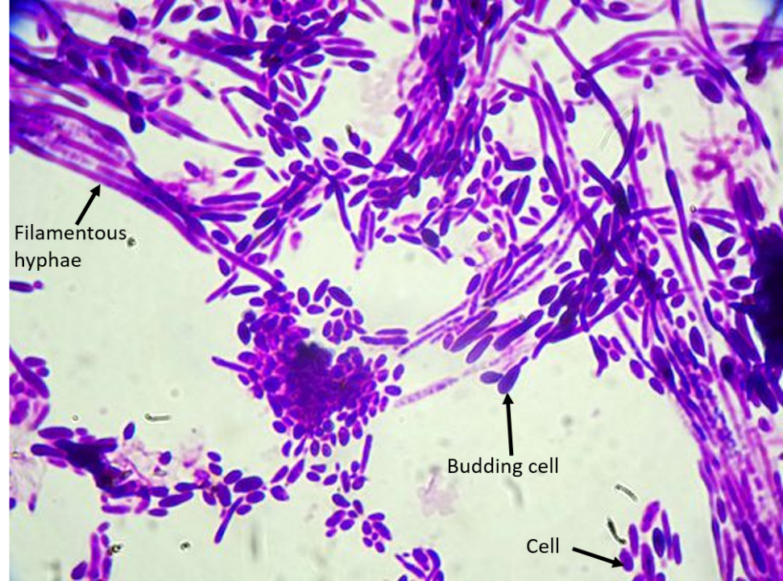
Downloaded 4/17/18. Photo by By Stefan Walkowski [CC BY-SA 4.0 (https://creativecommons.org/licenses/by-sa/4.0)], from Wikimedia Commons

Inclusion Bodies
Inclusion bodies occur in bacteria and can contain nutrients enclosed in single-layered membranes. Priestia megaterium (Pm) produces inclusion bodies that store polyhydroxyalkanoate (PHA), which is an energy storage molecule. PHA can also be harvested and used to create bioplastics that are biodegradable.
We can grow Pm in the lab, Gram stain it, and observe both the inclusion bodies and uneven staining typical of Pm as it ages. The inclusion bodies are kind of cool, and observing the odd staining patterns along with the inclusion bodies might help you on your unknown identification project. Bacillus subtilis reacts similarly to Pm, in case you get Bs.

Figure 6-4. Inclusion bodies and uneven Gram staining in Priestia megaterium
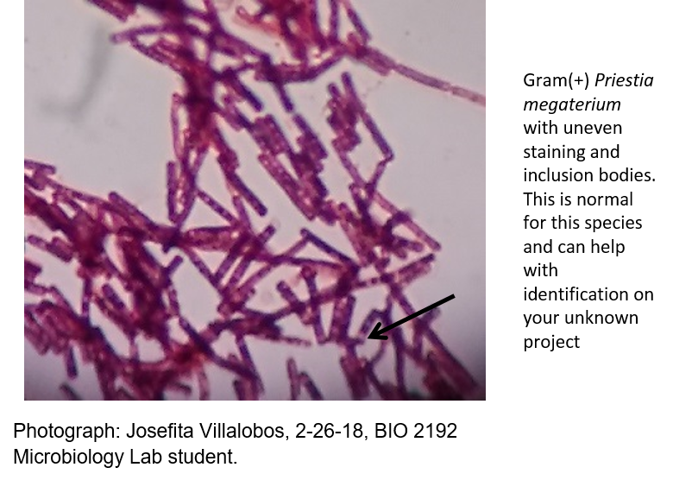

Endospores
Some types of bacteria, such as those in the genera Bacillus and Clostridium, form endospores inside their cells when conditions are harsh. Endospores contain DNA surrounded by a protective coat that can protect the DNA for (in some cases) millions of years! When conditions are ideal, the spores can germinate into a new cell.

Figure 6-5. Endospores.
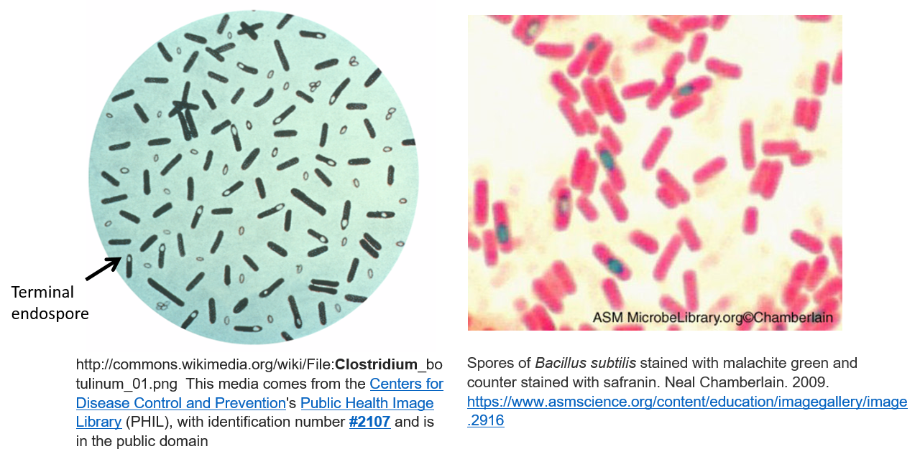

Capsules
Capsules form around the outside of the bacterial cell and are typically made of mucopolysaccharides. They are kind of slimy! Capsules can protect cells from phagocytosis, a process whereby white blood cells detect and eat bacterial cells. Capsules can also help cells adhere to surfaces.

If Streptococcus pneumonia, which is normal flora in the throat, forms a capsule, it can evade phagocytosis and can cause pneumonia.

Streptococcus mutans lives in the human mouth. It forms a capsule that allows it to stick to teeth. That fuzzy feeling you get on your teeth after eating a sugary donut? Streptococcus mutans! They really like sucrose, and when sticking to your teeth and metabolizing table sugar, they can produce acids that decay teeth.

Figure 6-6. Capsules (clear) surrounding bacterial cells (stained blue or purple)
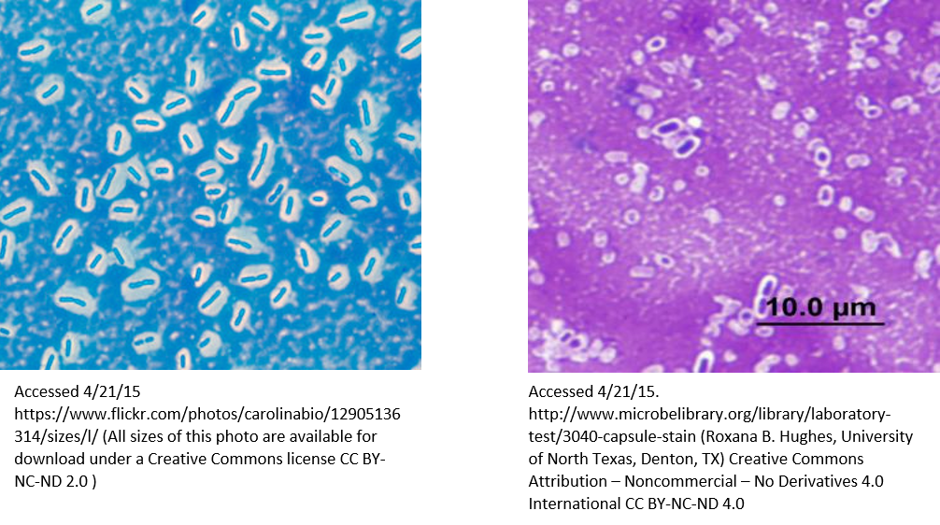

Flagella
Some bacterial species produce flagella, which are used for movement. The four types of flagella you should learn are:
- Monotrichous (“mono” means “one”)
- Amphitrichous (“amphi” means “both”)
- Lophotrichous (“lopho” means “cluster”)
- Peritrichous (“peri” means “covering”)

Figure 6-7. Left, Proteus vulgaris, peritrichous flagella. Right, Sprillum voltans, amphitrichous flagella
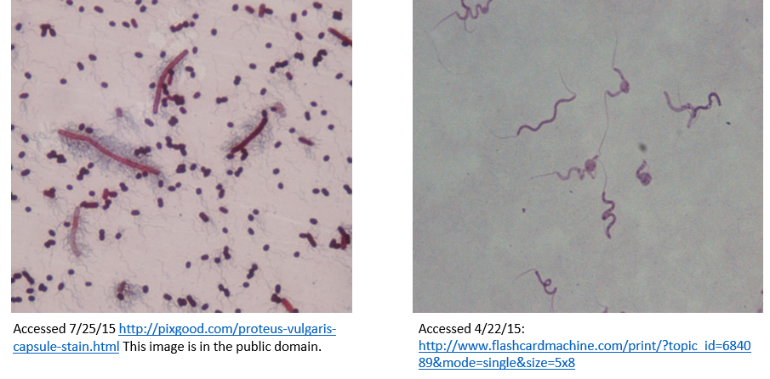

Procedure
- With your table-mates, set up six microscopes at your table.
- In the “Unknowns” box on your table, there are six slide types that are color-coded. Table members should divvy up the slides and focus each at 1000x TM.
- Your instructor will set up one additional slide off that may be projected on the screen at the front of the room.
- The different slides show unique organisms and features that you need to become familiar with for this lab:

- Inclusion bodies
- Endospores
- Capsules
- Mycobacteria (Acid Fast organisms) in lung tissue
- Amphitrichous flagella
- Peritrichous flagella
- Candida albicans (yeast)

In addition, you need to be able to identify and draw lophotrichous flagella and monotrichous flagella based on information in the introduction of this Unit.

- Working together with your lab-mates, use both the Dichotomous Key and the Flow Chart to identify all seven slides. Become familiar with both styles of keys.
- You may also use the pictures in the Unit, the “Reference Slide Set”, or you can consult your instructor if you get stuck.
- There are empty boxes on this handout in which to draw all seven specimens. Please DRAW and LABEL as instructed.
- By working with your lab mates, you will probably finish early. If you did not have time to finish in class, use the Internet and/or the photos in the lab manual and finish at home. You may receive credit for your efforts!

WRITTEN DICHOTOMOUS KEY
List of organisms

Proteus vulgaris
Flavobacterium capsulatum
Spirillum volutans
Priestia megaterium
Mycobacterium tuberculosis in lung tissue
Candida albicans

Clostridium sp.

- Are flagella present?
Yes. Go to 2. Proteus vulgaris or Spirillum volutans
No. Go to 3. Mycobacterium tuberculosis, Flavobacterium capsulatum, Candida albicans, Clostridium sp. or Priestia megaterium

- Are the flagella all over the cell so that the cell looks “hairy”?
Yes. This flagellar arrangement is called peritrichous. The species on the slide is Proteus vulgaris.
- Draw this cell with its peritrichous flagella in the box provided.
- Label: The cell and the flagella.

No. The flagella are at either end of the cell instead of all over.
This flagellar arrangement is called “amphitrichous”. The species on the slide is Spirillum volutans.
- Draw this cell with its amphitrichous flagella in the box provided.
- Label: The cell and both of the flagella.

- Are there red bacillus-shaped cells clumped together among blue lung tissue cells?
Yes. The red rod shaped cells are Mycobacterium tuberculosis.
This specimen was stained using the Acid Fast procedure. The blue is the lung tissue. The red color of the M. tuberculosis is due to the primary stain, carbolfuchsin, sticking to the mycolic acid. The blue is due to the secondary stain, methylene blue, sticking to the lung cells. Mycobacterium tuberculosis is the causative agent of tuberculosis.

- Draw a picture that includes the RED ROD-SHAPED Mycobacterium tuberculosis cells as well as the BLUE nucleated lung cells.
- Label some RED ROD-SHAPED Mycobacterium tuberculosis cells.
- Label a BLUE (with blue nucleus) epithelial cell.

No. Go to 4. Flavobacterium capsulatum, Candida albicans, Clostridium sp. or Priestia megaterium

- Are there clear halos around the bacillus-shaped cells or groups of cells?
Yes. The species is Flavobacterium capsulatum.
The halos are mucopolysaccharide capsules surrounding the cells. They can protect the cell from phagocytosis by immune system cells. Capsules may also be used by cells to stick to surfaces. Streptococcus pneumonia, a species we use in lab, has a capsule to help it evade the immune system (and can cause pneumonia). We will grow this in a culture later. It looks slimy!
- Draw an encapsulated cell (or cells).
- Label the cell and the capsule.

No. Go to 5. Priestia megaterium, Candida albicans or Clostridium sp.

- Is there a single ovoid structure inside some of the bacterial cells?
Yes. The slide shows endospores in Clostridium sp.
Some spore forming species are pathogenic like Bacillus anthracis (which causes anthrax) or Clostridium botulinum (which causes botulism), while other species are benign.

Endospores are formed when conditions are poor for the cell. Endospores form inside the cells but are eventually released as the cell degrades. A single cell can form only one endospore. Endospores can preserve DNA and other molecules for very long periods of time. The DNA is activated and the endospore germinates when favorable conditions are once again encountered.

- Draw one cell that contains its one endospore.
- Label the cell.
- Label the one endospore.

No. Candida albicans or Priestia megaterium. Go to 6.

- Are the cells larger than most bacterial cells and are there hyphae and budding cells?
Yes. This is the eukaryotic yeast, Candida albicans. It can cause yeast infections in humans and grows so well in laboratories that it often contaminates other cultures! (We do not grow it for that reason.)
- Draw one cell with its nucleus and label the cell and the nucleus.
- Draw a budding cell and label it.
- Draw filamentous hyphae and label it.

No. The specimen is bacillus in shape and shows uneven staining, even though it is Gram (+). It also has multiple dark purple inclusion bodies inside. It is Priestia megaterium, a large (for bacteria) non-pathogenic soil dwelling species.
- Draw one bacillus-shaped cell with the inclusion bodies.
- Label the cell and the inclusion bodies.

Dichotomous keys can be arranged in a flow chart format, also. In addition, the characteristics used can vary. Note the written dichotomous key does not follow the same order as the flow chart style that is show on the next page, but they both isolate all seven slide examples.

Post-Lab Questions Name: ____________________

- How can the presence of a capsule make a bacterial cell more pathogenic?

- Label the flagella types shown below.
Image created by Patricia G. Wilber, 2015

- How do flagella contribute to bacterial pathogenicity?

- Give an example of a disease caused by a bacterial species that has an Acid Fast cell wall.

- What are endospores and what advantage do they give to bacteria that can form them?

- Describe two differences between yeast cells and bacterial cells.

- Draw a cell with ONE endospore (that’s all they make) and a cell with multiple inclusion bodies.

- Give an example of a material that might be stored in an inclusion body. (You can look it up online or in your textbook or use the information in the lab manual to answer this).

- Create your own written Dichotomous Key or Flow Chart using the following six items. Keep a running list, as in the examples, after each question. This helps you keep track of the items you are working with and it helps the instructor follow your logic. You will use this technique for your Unknown Project.
sunflower, wrist watch, dry erase marker, dark chocolate bar, white chocolate bar, baseball cap

