Unit 8: Oxygen Utilization, Streak Isolation and Introduction to Bacterial Identification
By Patricia Wilber, Karen Bentz , Heather Fitzgerald and Andrea Peterson, 2022
Creative Commons Attribution-NonCommercial 4.0 International License.

Oxygen Utilization

Introduction:
Bacteria have varying oxygen requirements and usage abilities and these differences can be used to help identify bacterial species. Two quick assays used to check for oxygen usage are the catalase and oxidase tests. They are often called “spot tests” because they produce results immediately, or “on the spot”. The information from the catalase and oxidase tests can also be used to understand more about the metabolism being carried out in the bacteria.

Terms describing oxygen utilization:

Obligate aerobes:
Organisms that REQUIRE oxygen to survive. These organisms only get energy from aerobic respiration, using oxygen as their final electron acceptor in the electron transport chain. Mycobacterium tuberculosis and Nocardia asteriodes are obligate aerobes.

Facultative anaerobes:
Organisms that use aerobic respiration in the presence of oxygen, and in the absence of oxygen perform fermentation and/or anaerobic respiration.
These organisms tend to grow best in the presence of oxygen and go anaerobic facultatively (i.e. as needed) when oxygen concentration is lower than they prefer. Many (but not all) of the organisms we use in lab are facultative anaerobes.

Microaerophiles:
Organisms that do best when environmental oxygen levels are lower (2-10%) compared to normal atmospheric levels (21%) and MAY also prefer elevated CO₂ levels (capnophiles). Microaerophiles REQUIRE oxygen to live and have an electron transport chain. Campylobacter and Helicobacter species are microaerophilic and capnophilic.

Obligate anaerobes:
Organisms that do not use oxygen and are killed by oxygen. We do not have any of these in lab because they are hard to grow. Clostridium species are obligate anaerobes. Clostridium difficile forms endospores when exposed to oxygen because the vegetative cells are killed by the high oxygen levels.

Aerotolerant anaerobes:
Organisms that live by fermentation and do NOT use oxygen for metabolism. However, unlike obligate anaerobes, aerotolerant anaerobes are not killed by oxygen.

Figure 8-1. Growth patterns for various oxygen utilization strategies.
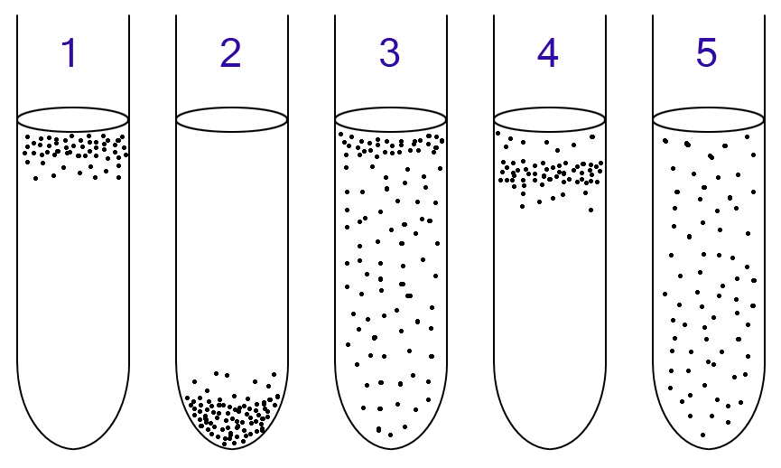
Retrieved 6/8/15 from http://en.wikipedia.org/wiki/Microaerophile. This picture is in the public domain.

Oxygen Utilization Exercise
Apply the terms for oxygen usage to the tubes in Figure 8.1 and complete the following table

Tube # | Oxygen utilization category | Aerobic respiration?  Yes or No | Defense  (write why you made your choices for columns 2 & 3 here)
1

2

3

4
5
Answers are at the end of Unit 8.

Streak Isolation from a mixed broth:
In medicine, samples from patients are rarely delivered in a pure culture, so perfecting a streak isolation and being able to recognize different colonies is really important!

Day I

Materials
- 1 Chocolate agar plate per student.
- Bacterial Culture: 0.5 ml Streptococcus pyogenes (Spy) mixed with 5 ml Priestia megaterium (Pm) in one T-Soy broth tube.
NOTE: Pm cells grows on top of the broth, some stick on the sides and LOTS of the cells cling to the bottom of the tube. Thus, you MUST STIR this broth with your sterilized loop to be sure to get enough of the Pm mixed in with the Spy to get both on your streak isolation!

Procedure
- Refer to Unit 3 to review the streak isolation procedure from a broth.
- A broth tends to be easier to streak from than a plate.
- STIR your mixed broth thoroughly with your sterilized loop before streaking!
- Tap your loop to reduce bacteria before performing the streak isolation.
- Perform your streak isolation on your chocolate agar plate.
- Be sure to label your plate correctly.

Figure 8-2. General procedure for the Streak Isolation Technique.
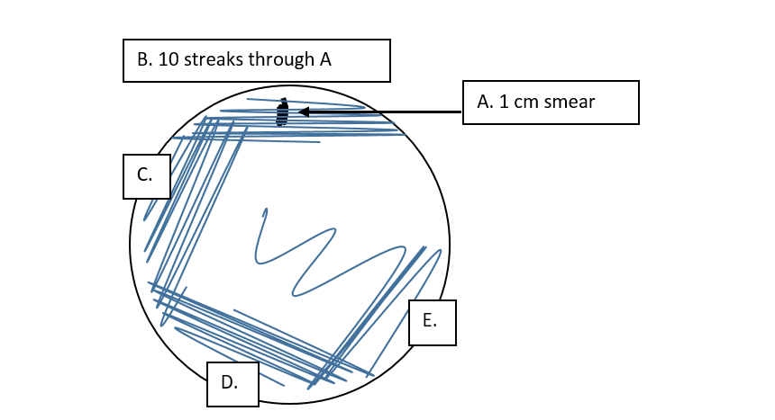
Figure by Patricia G. Wilber

Catalase Test

Introduction
Hydrogen peroxide (H₂O₂) is produced during aerobic metabolism and is toxic in high concentrations because cellular compounds are damaged by the oxidizing effects of H₂0₂. Many organisms that perform aerobic metabolism produce the catalase enzyme to detoxify the H₂O₂ by breaking it into water and oxygen. (Some bacteria produce other enzymes like peroxidase that carry out the same general reaction to detoxify H₂O₂.)

Here is the chemical reaction carried out by catalase:
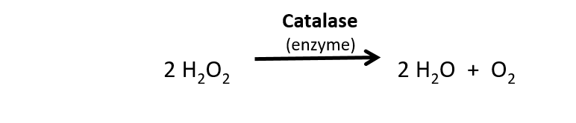
In the catalase test, we put bacteria into H₂O_{2.} Bubbling is a positive result and indicates that the organism produces the enzyme catalase. If there is no bubbling, the organism is negative for the catalase test which means the organism does not produce the enzyme catalase.

Organisms that are catalase positive might be obligate aerobes (all have catalase) or facultative anaerobes (many have catalase).

Organisms that are negative for the catalase test (no bubbling) lack the enzyme catalase. HOWEVER, there are other enzymes (like peroxidase) that break down H₂O₂. Therefore, a negative catalase test result does NOT indicate that an organism is an anaerobe.

Clinically, the catalase test is primarily used to differentiate Staphylococcus species (catalase +) from Streptococcus species (catalase -), and Clostridium species (catalase -) from Bacillus species (catalase +).

Do the Catalase Test
- Catalase Test https://youtu.be/mtK91MOd650
Video created by Corrie Andries and Karen Bentz

Materials: (per pair)
- 1 Wooden dowel for every TWO cultures tested (use both ends)
- 3% solution of hydrogen peroxide
- Glass slides
- Cultures
  - Enterococcus faecalis (Ef)
  - Streptococcus oralis (So)
  - Pseudomonas aeruginosa (Pa)
  - Staphylococcus saprophyticus (Ss)

Procedure:
- Put your slide on the black table top.
- Pour a dime-sized puddle of hydrogen peroxide on the slide.
- Using your wooden dowel, put the flat end on top of one single colony and push gently so some bacteria sticks to the dowel. Do not gouge the agar.
- Place the end of the dowel with the bacteria on it into the hydrogen peroxide on the slide and let it sit there. DO NOT STIR. Do not remove it. (Bubbling will occur immediately if the test is positive.)
- Observe and record your results in Table 8.1.
- Dispose of the used dowel and slide in the Sharps container.

Results and Interpretation:
Figure 8-3. The results of the catalase test.
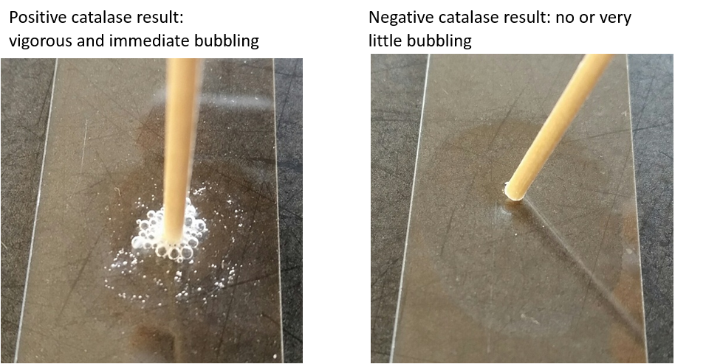
Photographs by Heather Fitzgerald

Table 8-1. Your Catalase test results and interpretation.
Organism Name | Gram(+) or (-) ?  (see table 8.5) | Catalase Test Results  (+ or -) | Does the bacteria produce catalase?  (Y or N) | Does the bacteria have the ability to perform aerobic respiration?  (Y or N or can’t tell)

Table 8.2. Relationship between oxygen usage category, respiration and catalase reaction.
Oxygen Utilization Category | Respiration | Catalase reaction
Obligate aerobe | Yes, does aerobic respiration | Always catalase positive
Facultative anaerobe | Yes, does aerobic respiration, and well as anaerobic | Some are catalase positive, some are catalase negative (have peroxidase instead)
Microaerophile and Capnophile | Yes, does aerobic respiration, some have anaerobic pathways | Always catalase negative
Aerotolerant anaerobe | Only anaerobic | Always catalase negative
Obligate anaerobe | Only anaerobic | Always catalase negative

Post Activity Question
- Based on the results you collected, which organism(s) might be:

  - aerotolerant anaerobes?

Defend your answer.

  - obligate aerobes?

Defend your answer.

Oxidase Test

Introduction
Indophenol oxidase, IF PRESENT, participates in the cytochrome oxidase complex which is the last step in the electron transport chain (ETC). The ETC is the final process of aerobic and anaerobic respiration. The cytochrome oxidase complex oxidizes cytochrome C and reduces oxygen. The oxygen can then combine with H⁺ to generate water as shown. Since this enzyme works with oxygen it is only useful for aerobic respiration processes.

Here is the chemical reaction carried out by indophenol oxidase:
Figure 8-4. The electron transport chain. Note the cytochrome oxidase complex. When the oxidase test is positive, indophenol oxidase is present.
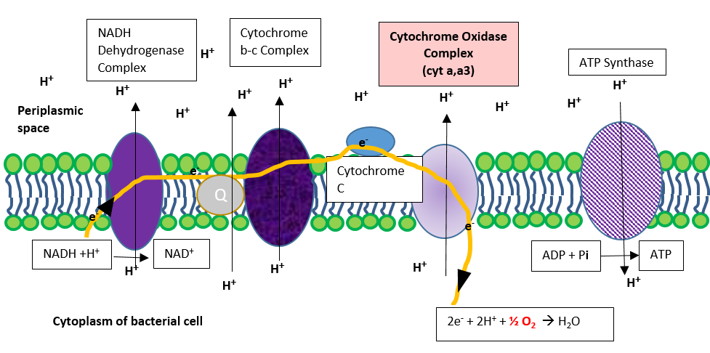
Image created by Patricia G. Wilber, 2015

The oxidase test works by providing a reagent which is oxidized by indophenol oxidase. The oxidation process turns the reagent purple. Organisms that show a positive reaction (purple) in the oxidase test therefore have an ETC and can perform aerobic respiration. They may be obligate aerobes, facultative anaerobes or microaerophiles.

In the diagnostic lab, oxidase and catalase tests are often performed and reported together. The oxidase test is also useful to help distinguish the oxidase positive Pseudomonas, Nesseria, Helicobacter and Campylobacter species from other Gram(-), rod shaped bacteria that commonly live in the intestines.

Do the Oxidase Test
- Oxidase Test https://youtu.be/F_ehe8l9m-Y
Video created by Corrie Andries and Karen Bentz

Materials: (per pair)
- 4 wooden dowels/sticks
- Oxidase reagent (in an ampule)
- Paper towel
- 4 pieces of Bibulous paper
- Cultures

  - Enterococcus faecalis (Ef)
  - Streptococcus oralis (Sm)
  - Pseudomonas aeruginosa (Pa)
  - Staphylococcus saprophyticus (Ss)

Procedure:
- Put the four pieces of bibulous paper on a paper towel.
- Using your wooden dowel, put the flat end on top of one single colony of the bacteria being tested (to get a single species in case of contamination) and push gently so some bacteria sticks to the dowel.
- Place the end of the dowel on the bibulous paper and rub the bacteria onto the paper.
- Put a few drops of oxidase reagent on the bibulous paper next to the rubbed in bacteria and let the reagent bleed over into the bacteria.
- Observe your results. A positive reaction will turn the paper purple within 5-30 seconds and a negative reaction will be no color, yellowish or sometimes pinkish within the 30 second time frame. Do not record results obtained after 30 seconds.
- Record your results in Table 8-2.
- Dispose of the bibulous paper and paper towels in the biohazard bucket.
- Put the wooden dowels in the sharps container.

Precautions:
- Use a platinum or wooden stick.
- Use fresh (less than 24 hours old) colonies (those provided in this class are fresh).
- Colonies should be at room temperature prior to testing.
- Use ONLY colonies grown on non-selective, non-differential media. If you try the oxidase test using bacteria grown on a MacConkey’s plate, for example, the result virtually always appears positive because of the purple crystal violet in that medium.

Results and Interpretation:
Figure 8-5. Oxidase test results
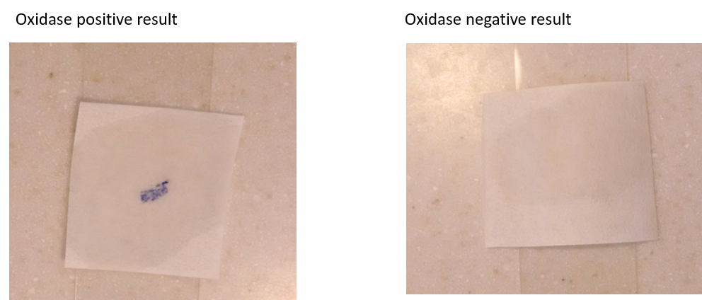
Photographs by Andrea Peterson, 2015

Positive test result:
The bibulous paper turns purple within 5-30 seconds. DO NOT consider the result positive if the color change occurs later than 30 seconds.

If the organism is positive for the oxidase test, the organism has produced the enzyme indophenol oxidase. Since the enzyme indophenol oxidase uses oxygen in the ETC, the oxidase positive organism CAN perform aerobic respiration. An oxidase positive organism might be an obligate aerobe, a facultative anaerobe, or a microaerophile. POSITIVE RESULTS ARE RARE. Most oxidase negative organisms use a different enzyme in the last step of the ETC.

Negative test result:
If there is no color change to purple within 30 seconds, the oxidase test is considered negative. Therefore, the organism tested does not produce the enzyme indophenol oxidase. Remember most species are oxidase negative and use a different enzyme in the last step of the ETC. If the result is negative, we have ONLY learned that the organism tested lacks the enzyme indophenol oxidase.

Table 8-3. Your Oxidase test results and interpretation.
Organism Name | Gram(+) or Gram(-)?  (see table 8.5) | Oxidase test results  (+ or -) | Does the bacteria produce indophenol oxidase?  (Y or N) | Does the bacteria have the ability to perform aerobic respiration?  (Y or N or maybe)

Table 8-4. Relationship between oxygen usage category, respiration and oxidase reaction
Oxygen Utilization Category | Respiration | Oxidase reaction
Obligate aerobe | Yes, only performs aerobic respiration | A few species are positive
Facultative anaerobe | Yes, performs aerobic respiration, and well as respiration without oxygen | A few species are positive
Microaerophiles and capnophiles | Yes, does aerobic respiration, and well as respiration without oxygen | A few species are positive
Aerotolerant anaerobe | Does not perform aerobic respiration | Always oxidase negative
Obligate anaerobe | Does not perform aerobic respiration; poisoned by oxygen | Always oxidase negative

Post Activity Question:
- Based on your oxidase test results, which of the bacteria might be:
- aerotolerant anaerobes?

Defend your answer.

- Obligate aerobes?

Defend your answer.

INTRODUCTION TO BACTERIAL IDENTIFICATION

Introduction:
In a clinical setting, identifying an unknown bacterial pathogen is critical for proper treatment. A number of procedures are generally used to ensure an accurate identification of the bacteria.
A dichotomous key will yield an efficient pathway for unknown bacterial identification.

Bacterial Identification Exercise:
In this exercise, you will use the information in Table 8.5 to construct a dichotomous key which could then be used to identify unknown bacteria. This is similar to what you will be doing for your Unknown Identification project later in the semester.

George is a Bio 2310L student and he is attempting to identify an unknown bacterial species that is one of the 16 listed in Table 8-5. He did a catalase test on his unknown bacteria and found bubbling.

George used the information from his catalase test to compose his first dichotomous key question:
Dichotomous Key Question 1: Did the organism bubble as a result of the Catalase test?
Yes: (List those that would bubble) No: (Those that would not bubble)

- Using Table 8-5 (below), find and list all the organisms that would show bubbling and all that would not show bubbling. You may abbreviate the organism names. Put the names in the correct places above.

- Circle the list that contains George’s unknown bacteria.

George next did a Gram stain and found he had purple cells that were rod shaped. This test results in TWO questions for the identification process.

George then came up with these two additional dichotomous key questions to further identify his unknown species, which he knows is catalase positive, Gram(+) and rod shaped.

Dichotomous Key Question 2: Is the organism Gram(+)?
Your circled list from Dichotomous Key Question 1 contains George’s possible bacteria. Work from that list for Dichotomous Key Question 2 to make the new lists below. You can also refer back to Table 8-5.

Yes: bubbled and purple No: bubbled but not purple

- Circle the list from Dichotomous Key Question 2 that contains George’s unknown bacteria.
Dichotomous Key Question 3: Is the organism bacillus in shape?
Your circled list from Dichotomous Key Question 2 contains George’s possible bacteria. Work from that list for Dichotomous Key Question 3 to make the new lists below. You can also refer back to Table 8-5.

Yes: bubbled, purple, rod shape No: bubbled, purple, not a rod shape

- Circle the list that contains George’s unknown bacteria.

Dichotomous Key Question 4: Finally, George did an oxidase test and he got purple on his bibulous paper. He should now be able to identify his organism.

Remember: Your circled list from Dichotomous Key Question 3 contains George’s possible bacteria. Work from that list for Dichotomous Key Question 4 to identify George’s species. You can also refer back to Table 8-5.

- Write the Dichotomous Key Question 4 for the oxidase test.
Your Dichotomous Key Question 4:

- Write the full name of George’s organism in proper scientific format.

Table 8.5. Expected Results for Gram(-) and Gram(+) Bacteria
Gram(-)Bacteria | Cell Shape | Catalase | Oxidase | Gram(+) Bacteria | Cell Shape | Catalase | Oxidase
Escherichia coli | rod | (+) | (-) | Bacillus subtilis | rod | (+) | (-)
Aggregatibacter aphrophilus | rod | (+) | (+) | Staphylococcus aureus | cocci | (+) | (-)
Proteus vulgaris | rod | (+) | (-) | Priestia megaterium | rod | (+) | (+) or (-)
Shigella flexneri | rod | (+) | (-) | Staphylococcus saprophyticus | cocci | (+) | (-)
Psuedomonas aeruginosa | rod | (+) | (+) | Streptococcus oralis | cocci | (-) | (-)
Citrobacter freundei | rod | (+) | (-) | Streptococcus pneumonia | cocci | (-) | (-)
Klebsiella pneumoniae | rod | (+) | (-) | Streptococcus pyogenes | cocci | (-) | (-)
Serratia marcescens | rod | (+) | (-) | Enterococcus faecalis | cocci | (-) | (-)

DAY 2: Streak Isolation Results and Interpretation
Hopefully, your results show clear isolation like this: (You have different species though and this is a blood plate, not a chocolate agar!)

Fig. 8-6. Successful streak isolation of two species on a TSA blood plate.
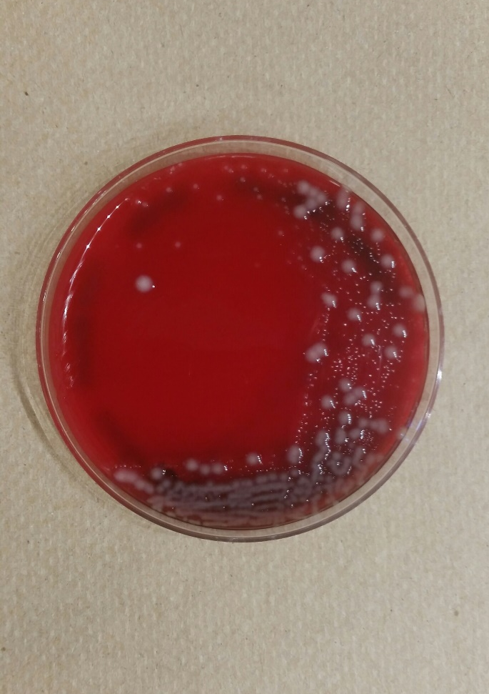
Plate by Leanna Gutierrez, Bio 2192, Spring 2016.
On your plate, you should see some big grayish, flat and not shiny colonies. These are Priestia megaterium. You should also see some tiny colonies. These are Streptococcus pyogenes.

Insert a photo of your streak isolation here. Compare it to the picture above.

- Find and describe your two isolated colonies.
* If you did not get isolated colonies find a classmate that has them and really look at the colonies and describe theirs.

- Work with people at your table to Gram stain three specimens. Then draw what you see. It would be best if each person does one of the following Gram stains to practice the staining procedure. No one should need to stain more than one specimen type. (You might repeat your staining procedure if the stain turns out poorly, but check with your instructor before you do.)
  - Use isolated colonies of the bigger flatter type for two Gram stains.

  - What species is this bigger flatter colony?_______________________
    - Gram stain 1: One person should stain one isolated domed (younger) colony of the bigger flatter type (which may lack inclusion bodies).
- Draw some cells.
- Name the cell shape.

    - Gram stain 2: One partner should stain one flatter (older) colony of the bigger flatter colony type (which should contain inclusion bodies).
    - Draw some cells with inclusion bodies..
    - Label the inclusion bodies.
    - Make notes about the uneven staining of the cells. This may help you on your unknown project if you get Pm or Bacillus subtilis.

    - Name the cell shape. _____________________
    - Determine the cell size. They are very large.___________________________

  - Gram stain 3: Gram stain one isolated colony of the smaller type.

  - What species is the smaller colony type? ________________________
- Draw some cells.
- Name the shape.____________________________

Fig. 8-7 Photomicrograph of Gram (+) Priestia megaterium from an older colony. Note the inclusion bodies and that the stain looks somewhat uneven due to the inclusion bodies and the degradation of the peptidoglycan of the cell wall as the cell ages. The arrow points to a cell with inclusion bodies.

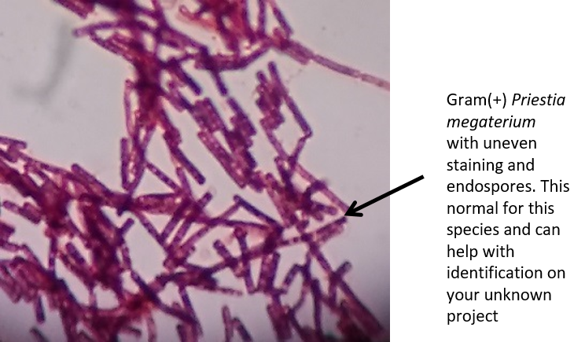

- If you have time, you can catalase test the Pm and/or the Spy, directly on the Chocolate plate.
  - Which species is catalase positive?_________________________

- If you did not have two colonies which of these might be the reason?
  - You did not stir the broth adequately before streaking. The Pm grows on the top of the broth, so it just might have been missed.
  - You used too much bacteria so one over-ran the other.

If, at this point, you still cannot perform a correct streak isolation pattern and achieve isolated colonies, YOU MUST figure out why this is so. In any case, answer the following questions.

The main things to consider are:
- Have you mastered the basic pattern? YES or NO.
  - If no, look at the pattern in U3, look up streak isolations online and practice the pattern on a piece of paper to develop muscle memory.

- Are you using too much bacteria? YES or NO.
  - If yes, USE LESS! Touch your loop to a solid colony if using a plate; do not scoop it. Tap the excess liquid off your loop if using a broth.

- Did you sterilize your loop between sections? YES or NO.
  - If no, just remember to use that incinerator!

- Are you overlapping too much? YES or NO.
  - If yes practice the pattern with (see 1) with less overlap between sections. You must overlap some, though. No overlap = no bacteria to spread to the next section.

Post Lab Questions Name ________________________

- Write out the chemical equation for the:

Catalase reaction

Oxidase reaction

- Based on the results of your catalase and oxidase tests, list one organism you tested that could be a facultative anaerobe.

Defend your answer using the data you have collected earlier in this unit.

- Clinically, when is the catalase test often used?

- True or False: If an organism is catalase positive, it is always a Staphylococcus species.

Defend your answer.

- Clinically, when is the oxidase test most often used?

- True or False: If an organism is oxidase negative, it is always anaerobic.

Defend your answer.

- Use the information in Table 8-5 to complete the following table.
Catalase Test  Result | Oxidase Test  Result | List up to two possible organisms | Possible oxygen utilization type(s)
bubbles | purple
bubbles | not purple
no bubbles | purple
no bubbles | not purple

  - If you have properly done a streak isolation with a mixed broth containing a Staphylococcus species and a Bacillus species, how many different colony types should you see?

  - If you Gram stained one colony type and you found the cells to be round and in clumps, which Genus are you observing?

  - Without Gram staining, predict identity of the other colony type. YOU WOULD HAVE TO GRAM STAIN TO VERIFY, HOWEVER, and you could not just assume.

- Priestia megaterium forms inclusion bodies. Will you be able to recognize them if you see them again? If not draw some more pictures.

Answers for Figure 8-1.
Tube # | Oxygen utilization category | Aerobic Respiration? | Defense
1 | obligate aerobe | YES | growing only at top where there is oxygen
2 | obligate anaerobe | NO | growing only at bottom where there is no oxygen
3 | facultative anaerobe | YES | growing throughout the tube but the population size is bigger at the top where there is oxygen
4 | microaerophile | YES | grows best with small amounts of oxygen; many microaerophiles are also capnophilic
5 | aerotolerant anaerobe | NO | grows equally well throughout the tube without regard to oxygen concentration

